The email Centenary Birthday Party A.G.B.I. Raffle 2022

Amazing Prizes, An exquisite necklace in memory of Caroline Benyon, Glass and Equipment Vouchers, Books, Workshops and Webinar tickets to be won!!

“The AGBI Raffle 2022 Strip of Five” and above

5 tickets and 5 chances every strip for every prize!!
The more strips of five you buy the more free tickets
you receive and may win !!!

Everyone across the country can take part in raising money for our annual Artists’ General Benevolent Institution/BSMGP Collection …. so please can you buy 5 Tickets at £5 per strip by email and pay via the BSMGP website shop now!
on www.bsmgp.org.uk/product-category/raffle-tickets/

“The life of an artist can be precarious at the best of times, but when ill health renders an artist unable to work and earn, their circumstances can quickly deteriorate.
Your support and donations enable the AGBI to continue its vital work during these challenging times and we expect the demand for our services to rise”

The Draw will take place at the B.S.M.G.P. Centenary Party on 1st July at the Art Workers Guild in London. (if you are at the Party tickets will also be sold individually)

If you will not be at the party and one of the you lucky prize winners your prize will be sent to you! So please email the form back with your prize choices. Many prizes have been sent as far as Scotland and Wales before –
so it does happen and it could be you!

And why not encourage your staff, friends and colleagues to buy some as well !

The AGBI is the only national benevolent fund targeted specifically to support artists in time of need.
The support is person-centred, non-judgemental, delivered with compassion and strictly confidential.

All the money raised from the AGBI Raffle will be given into our 2022 Artists’ General Benevolent Institution BSMGP Collection. The BSMGP raises an official collection along with 12 other arts societies and is highlighted each year in the AGBI’s Annual Impact Report. The AGBI was founded by members of the Royal Academy of Arts including JMW Turner and John Constable and is one of the oldest charities in the UK (Patron HRH Prince of Wales)

AGBI grants of financial assistance are given to professional artists, including stained glass artists, who have fallen on hard times and who cannot work in the short or longer term. This may be due to an illness, accident, or injury or in old age and in retirement needing specialist medical care or help with basic bills.

As one artist said:
“My situation was very bleak at the beginning, I found myself weakened, distraught and in shock at my diagnosis. I do not exaggerate when I say your support was a lifeline giving me some hope, a sense that people were looking out for me”

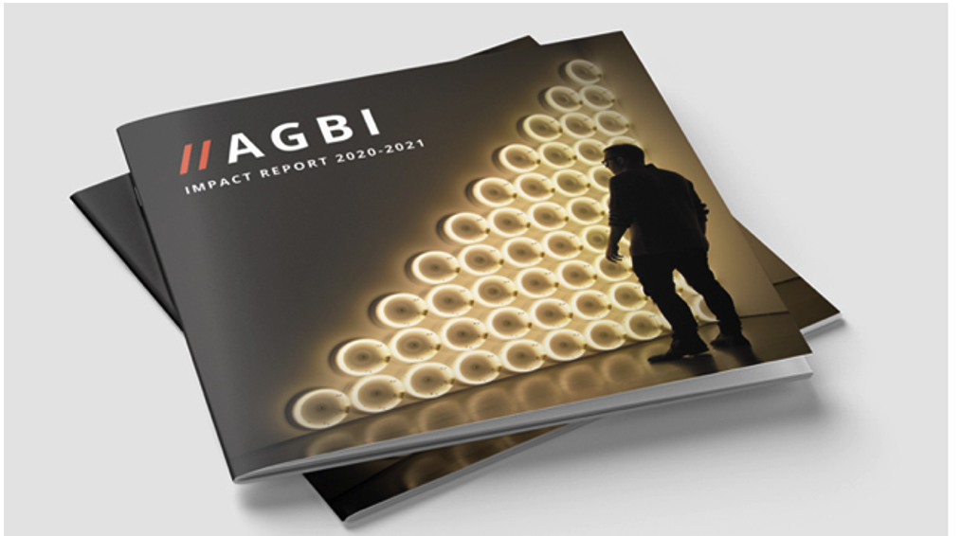

Prizes include:

An exquisite necklace by Pippa Martin
– offered in memory of Caroline Benyon FMGP

Creative Glass Guild, Bristol - £100 Complimentary Voucher
Creative Glass Guild has been at the cutting edge of stained and art glass in the U.K. since it began in 1979. Over 2,500 products for stained glass, glass painting, fusing, bead-making and jewellery enthusiasts, books, tools and kilns are available to choose from! It also runs an extensive range days of taster days and weekend courses for all levels in their well-equipped studio. To be spent at the shop/online & delivery
www.creativeglassguild.co.uk

Two Prizes of ‘Three Complimentary BSMGP Webinar Tickets £15’

Pearsons Glass uk - £75 Complimentary Voucher
One of the largest suppliers of stained glass and fusing products in the U.K. The modern warehouse is based in Liverpool. A shop online facility containing an extensive catalogue of stained and fusing glass, tools and equipment. Also, Glass and Mirror Processing. To be spent at the shop/online & delivery
www.pearsons-glass.co.uk

A Stained Glass Day £150 with Rachel Mulligan AMGP
Discover your inner artist in a one-day stained glass workshop with Rachel Mulligan. Skills include glass cutting, engraving, painting, staining, leading and soldering. Excellent results are achieved because only mouth-blown glass is used. Suitable for all levels. Includes lunch.
www.rachelmulligan.co.uk

Tatra Glass - £75 Complimentary Voucher
Tatra Glass UK was formed in 1990 specifically to import antique stained glass, glass bullions and rondels from Poland. Suppliers of Stained and Restoration Glass. Now has a stock holding over 6000 square metres of stained glass consisting of over 160 colours, 30,000 glass rondels and 500 glass bullions. To be spent at the shop/online & delivery
www.tatra-glass.co.uk

2 prizes of Stained Glass: Art, Craft and Conservation by Steve Clare FMGP (£30)
This very popular book by Steve Clare is richly illustrated with both practical work in progress images and examples of the splendour of stained glass both in its historic and contemporary forms.
www.holywellglass.com

A Glass Painting Day - £170 with Andrew Taylor FMGP
To explore different aspects of glass painting at his studio in Wiltshire. “Vitreous paint applied and fired onto glass transforms the material in a remarkable way, so another dimension of expressing ideas and feelings is facilitated.” Including all equipment and materials (+refreshments)
www.andrewtaylorarts.co.uk

Kilncare - £50 Complimentary Voucher to be spent at Warm Glass UK
Kilncare is known as ‘Britain’s one true, glass kiln specialist company.’ A family business designing and producing kilns and glass equipment with a particular understanding of glass processes and creative minds. www.kilncare.co.uk
The Complimentary £50 Voucher to be spent at Warm Glass UK www.warm-glass.co.uk the leading fused glass supplier and the Bullseye Glass Preferred Partner for Europe. Shop/online & delivery

Please remember the AGBI is a confidential lifeline for stained glass artists like ourselves and our colleagues, of all ages and that includes you too!

Now just email back the prize form
And Good Luck!

“The AGBI Raffle 2022 Strip of Five” or more!

If you are unable to join us at the Centenary Birthday Party please return this form immediately by email to the AGBI Steward Jane Campbell to jcampbellglass@icloud.com by the 29th June and if you are a lucky winner we will select your prize according to your wishes and send it to you!
So Good Luck and Thank you!

Name:
Address:
Tel:
Email:
I have bought £ ……… of Tickets and paid via the BSMGP Website on www.bsmgp.org.uk/product-category/raffle-tickets/ or by cheque
The more tickets you buy, the more free tickets you receive!
Please remember all the money raised will go to ‘The Artists’ General Benevolent Institution (BSMGP) Collection’

Prizes – My Priority List | 1 = you like the most  9 = you like the least  X = you do not want
An exquisite necklace by Pippa Martin
offered in memory of Caroline Benyon FMGP

Creative Glass Guild - £100 Voucher

Prize of ‘Three BSMGP Webinar Tickets’

Pearson’s Glass UK - £75 Voucher

Stained Glass Day with Rachel Mulligan AMGP

Tatra Glass (UK) - £75 Voucher

Book- Stained Glass: Art, Craft and Conservation by
Steve Clare FMGP

Glass Painting Day with Andrew Taylor FMGP

Kilncare £50 Voucher to be spent at Warm Glass UK

(If you still prefer to send a cheque please write it to “The Artists’ General Benevolent Institution” and on the reverse side the (BSMGP Collection) and post to J. Campbell FMGP, AGBI Steward, 7 St Bartholomews Close, Chichester, West Sussex PO19 3EP)

